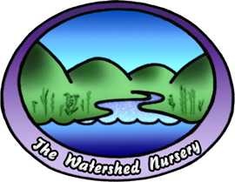
The Watershed Nursery
601 A Canal Blvd.
Richmond, Ca. 94804
510-234-2222
www.thewatershednusery.com

October 4, 2012

Codornices Creek 6th to 8th Street Reach Restoration Monitoring Summary
Project Description:
The Codornices Creek Watershed Council (CCWC) received a grant from the State Coastal Conservancy (SCC) to install both educational and habitat enhancing features to the planned riparian restoration project along Codornices Creek between 6th and 8th Streets in Berkeley, California being coordinated by the City of Albany and Restoration Design Group (RDG), LLC. The Urban Creeks Council, located in Berkeley California, is the fiscal sponsor and project manager for this project. The CCWC requested The Watershed Nursery (TWN) to provide locally appropriate native plants for this project with the following three initial focuses:
1) Three interior planting areas of the project site ‘Area A’ using a base palette of species choices/habitat types RDG has selected with additional species added to augment diversity or accommodate particular planting location conditions. Interior areas have been selected by slope and proximity to bike trail.
2) The eastern (8th St.) end of project ‘Area B’ around outdoor classroom and on north and south side of creek inlet, emphasizing educational aspects (ie. habitat value, Native American/medicinal uses).
3) Screening/habitat shrub species along northern portion of the project ‘Area C’ to supplement those installed by RDG.
The initial phase of planting was installed in the winter of 2011. In the following spring TWN conducted a qualitative survey of plantings to develop a fill-in or additional planting plan for the winter of 2011/2012 based on the results of spring 2011 survey. Supplemental plantings occurred in the fall of 2011 and a final follow up monitoring was conducted June 2012.

Monitoring Methods:
The monitoring plan for this area was always framed as a qualitative assessment. TWN also chose to collect some quantitative data related to survival and vigor. In June 2012 all areas were monitored for survival and vigor. The entire area was walked and plants of each species were counted and assessed with a 0-3 vigor rating, where 0 means the plant is dead, 1 means stressed, 2 means stable and 3 means the plant is actively growing.
The initial (2011) planting plan was changed during installation due to differences in construction topography versus design topography. Because of these last minute adjustments some species were moved between planting areas. In addition, some areas were sheet mulched and others were planted and mulched around individual plants only. Finally, all individual plantings were not marked or mapped. All of these factors make the survival data incomplete and not necessarily reflective of total survival so the more relevant aspect of this round of monitoring in terms of plant establishment is observed vigor for each species.
Results:
Area A: Areas between path and creek along the left bank (looking downstream) of creek.
This area was planted based on RDG’s meadow plant palette with some additional species to augment diversity. A subset of ‘Area A’ species was installed in the narrow stretch between the wall and the path rather than along the creek, in particular the Aristolochia californica and the majority of the Tellima grandiflora.
Table 1: Species planted on left bank/pathside of Codornices Creek 6th to 8th st. reach-
Area A
Species code | Species
AchMil | Achillea millefolium
AriCal | Aristolochia californica
ArtCal | Artemisia californica
ArtDou | Artemisia dougaliana
AstChi | Aster chilensis
BacDou | Baccharis douglasii
ChoPom | Chlorogalum pomeridianium
CleLig | Clematis ligusticifolia
DesCes | Deschampsia cespitosa
EscCal | Eschscholzia californica
EutOcc | Euthamia occidentalis
FraVes | Fragaria vesca
HerLan | Heracleum lanatum
IriDou | Iris douglasiana
JunPat | Juncus patens
LonHis | Lonicera hispidula
MimAur | Mimulus aurantiacus
MimCar | Mimulus cardinalis
MonVil | Monardella villosa
NasPul | Nassella pulchra
PerKel | Perideridia kelloggii
PhyCap | Physocarpus capitatus
PotAns | Potentialla anserine
RanCal | Ranunculus californicus
RhaCal | Rhamnus californica
RosCal | Rosa californica
RosGyn | Rosa gymnocarpa
RubUrs | Rubus ursinus
SatDou | Satureja douglasii
ScrCal | Scrophularia californica
SisBel | Sisyrinchium bellum
TelGr | Tellima grandiflora

Figure 1: Percent survival of species planted on left bank/pathside of Codornices Creek 6th
to 8th st. reach-Area A 2011 & 2012

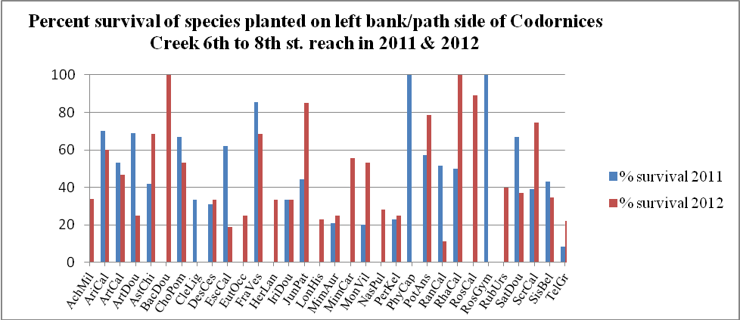
The average survival rate for all species in 2011 was 45% and 43% in 2012. As mentioned above the survival count is based on observable, unmarked individuals and species placements and counts have shifted so assessed survival is most likely an under estimation for most species.

Figure 2: Average vigor of species planted on left bank/path side of Codornices Creek 6th to 8th
st. reach 2011 & 2012
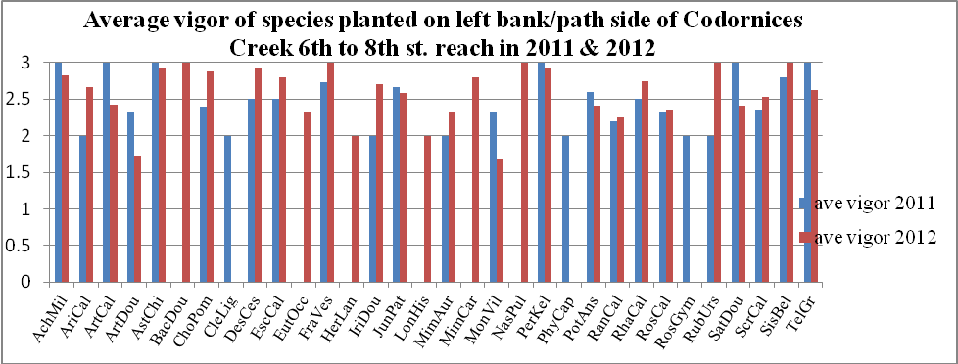
The average vigor in 2011 was 2.5 and 2.6 in 2012 which indicates that of the plants assessed the majority were well established with some demonstration of active growth. Active growth would be recorded if the plants showed new leaf growth, flowers, and/or fruit.
Area B: Outdoor classroom on floodplain and slope at the East end of reach.
This area includes the ‘flood plain’ and two sheet mulched areas below and above the wheelchair accessible path from the bike path to the outdoor classroom.
Table 2: Species planted within Area B
Species Code | Scientific Name
AchMil | Achillea millefolium
AriCal | Aristolochia californica
ArtDou | Artemisia douglasiana
AstChi | Aster chilensis
BacDou | Baccharis douglasii
CarBar | Carex barbarae
CleLig | Clematis ligusticifolia
CorCor | Corylus cornuta
DesCes | Deschampsia cespitosa
FesCal | Festuca californica
FraVes | Fragaria vesca
HeuMic | Heuchera micrantha
IriDou | Iris douglasiana
JunEff | Juncus effusus
JunPa | Juncus patens
JunXip | Juncus xiphipoides
LonHis | Lonicera hispidula
LonInv | Lonicera involucrata
MimAur | Mimulus aurantiacus
MimCar | Mimulus cardinalis
OemCer | Oemleria cerasiformis
PerKel | Periderdia kelloggii
PhyCap | Physocarpus capitatus
PolMun | Polystichum munitum
RanCal | Ranunculus californicus
RhaCal | Rhamnus californica
RibSan | Ribes sanguineum
RubPar | Rubus parviflorus
RubUrs | Rubus ursinus
SatDou | Satureja douglasii
SciMic | Scirpus microcarpus
ScrCal | Scrophularia californica
SisBel | Sisyrinchium bellum
SymAlb | Symphoricarpus albus
StaAju | Stachys ajugoides

Figure 3: Percent survival of species planted in outdoor classroom portion of Codornices 6th to
8th st. reach- Area B in 2011 & 2012

The average survival in Area B in 2011 was 85% and in 2012 was 67%. The ‘flood plain’ portion of Area B was a higher elevation than anticipated so some of the species planned were further from the water table than expected. One of these species in particular, Scirpus microcarpus, usually grows right at the toe of the slope. Due to the topography of the site this species would only be used in the future on the 6th st side of the project where a lower flood plain exists.
Initially it was expected that the slope of the lower sheet mulched area would be greater and thus have conditions more similar to a ‘northern exposure’ slope. Once the tree plantings develop some of the species in this palette may prove successful but for the time being the more shade loving plants such as the thimbleberry (Rubus parviflorus) and sword fern (Polystichum munitum) are struggling a bit. This was compounded during the spring and summer of 2012 because the irrigation system was broken and it took quite a while to get the City of Albany to assess and deal with the problem.
Figure 4: Average vigor of species planted in outdoor classroom portion of Codornices Creek 6th
to 8th st. reach –Area B in 2011 & 2012

The average vigor in 2011 and 2012 was 2.4 which indicates that in general, despite irrigation issues, most individuals were healthy and stable or putting on new growth. Two species had a dramatic decrease in vigor from 2011 to 2012. Both yerba buena (Satureja douglasii) and the California buttercup (Ranunculus californica) were not observed on site and dropped from a vigor assessment of 3 in 2011 to 0 in 2012. This was quite surprising in the case of the yerba buena because it had such vigorous growth in the areas where it was established in 2011. This may be a result of watering regime or potentially a competitive dynamic with the woodland strawberry which has a similar growth habit. Across the majority of other species vigor actually increased from 2011 to 2012 and with omitting the vigor values of the two species mentioned above and the Scirpus microcarpus, which has poor success in both years, the average vigor increasee in this area in 2012 to 2.6.

Area C: Plant selection designed to provide a screen and bird habitat along the right bank of the reach.
Table 3: Species planted along right bank of reach- Area C
Species Code | Scientific Name
BacPil | Baccharis pilularis
CeaThy | Ceanothus thyrsiflorus
HerLan | Heracleum lanatum
HetArb | Heteromeles arbutifolia
HolDis | Holodiscus discolor
LonInv | Lonicera involucrata
PhyCap | Physocarpus capitatus
RibMen | Ribes menziesii
RosCal | Rosa californica
SamMex | Sambucus mexicana
SamRac | Sambucus racemosa

Figure 5: Percent survival of species planted on north/right bank of Codornices Creek along 6th to 8th st reach 2011 & 2012
Average survival in 2011 was 92% and dropped to 67% in 2012. Survival of Baccharis pilularis increased in 2012 due to new recruits established from seed. Heteromeles arbutifolia also showed an increased survival which is most likely due to rebound of plants from initial planting stress, ie. not new plants but plants which were recorded as dead in 2011 monitoring.

Figure 6: Average vigor of species planted on the north/right bank of Codornies Creek along 6th to 8th st.
Reach 2011 & 2012

Average vigor ratings for Area C was 2.3 in 2011 & 2012. Although survival rates for most species decreased in 2012 the average vigor for most species was similar or higher in 2012 to vigor rates in 2011 and those individuals who had survived were well established, some flowering and fruiting. This is true except for the Ribes menziesii which is often beginning to go dormant by the time this monitoring was conducted.
Discussion/Management Strategies:
As stated previously this monitoring event was specified as being qualitative rather than quantitative. TWN proceeded with a more quantitative method but since every plant was not flagged there is a good chance that survival counts are lower (especially in Area A) than what is actually surviving at the site.
During the 2011 year the City of Albany had a crew visit the site roughly 1x/week to conduct maintenance activities. This maintenance included weed whacking of non-native grasses. The success of this management in facilitating the establishment of the seed mix is quite astounding. During spring 2012 substantial populations of Bromus carinatus and Nassella pulchra (now Stipa pulchra) were observed on the site most likely arising from the seed mix. This maintenance cycle was ceased in December of 2011 and it will be interesting to see how the grass populations shift in 2013 without this specific maintenance activity.
In 2012 the City of Albany engaged a private entity to conduct some maintenance activities along the creek but there are only 2 people who are tasked with addressing issues from 3rd street to 10th and so have not spent much time along the 6th to 8th street reach. As mentioned previously, TWN observed dry conditions on the site during a spring maintenance event and during the monitoring. It took quite a while to get the City to assess and correct the problem and it is clear there was some impact from this delay on plant growth and vigor.
In the fall of 2011 Kids for the Bay (KftB) proposed adopting this 6th to 8th street reach. After several months of discussion this was agreed to by the CCWC and KftB. The goal with this adoption is that KftB will take on some of the on-going maintenance activities at the site. As an initial project kids collected seed in the spring of 2012 from the site (with direction from Diana Benner with The Watershed Nursery), cleaned, treated, & sowed the seed. TWN then took care of the sown seeds until KftB dedication event on Oct. 20th 2012 at the site when KftB staff and volunteers installed the plants. Diana Benner, Dan Dole, and Mary Pearsall from CCWC were also on site assisting with the installation. The main KftB contacts have been Sheela Shankar and Bhavana Mody.
The irrigation issue has been resolved and the site was very wet during the Oct. 20th event. The site looked lush, ie. overwatered (both the planted natives and non-natives). The overall management strategies for the upcoming years should continue practices that increase the native seed input and decrease the non-native seed input. This will entail a combination of well timed planting and weeding efforts. Diana Benner (TWN) and Tony Wolcott (City of Albany) will work with KftB to assist in planning priorities for maintenance activities.
Although there is a good amount of non-native pressure on the site and successful establishment of a predominantly native plant palette will require on-going efforts, there are areas of the site where planted species are spreading both vegetatively and through new seedlings. This recruitment indicates that with continued efforts the site has good potential to support robust populations of a diversity of native plant species (and associated fauna).

